INTERNSHIP REPORT
Data Preprocessing and Standardization of Paneer Storage Study Data
Week 2 – Data Preprocessing
Student | Rishikesh Deshmukh
Internship organization | Yuva Intern
Internship role | Junior Data Scientist Intern – Food Processing
Week and task | Week 2 – Data Preprocessing
Technology | Python, pandas, NumPy, scikit-learn, Jupyter Notebook
Date of preparation | 10 October 2026

Dataset analysed: Storage study data for paneer in controlled RH and Temperature environment, Mendeley Data, Version 2, DOI: 10.17632/rd9dmr54xx.2 (CC BY 4.0).
Table of Contents
Abstract 2
1. Introduction 3
2. Objectives 3
3. Dataset Description 3
4. Tools and Technologies 4
5. Preprocessing Methodology 5
6. Before-and-After Comparison 6
7. Missing-Value Treatment 7
8. Outlier Analysis 7
9. Standardization 8
10. Results and Discussion 8
11. Challenges and Solutions 9
12. Conclusion 9
13. References 10

Abstract
This report documents the Week 2 data preprocessing task completed during the Junior Data Scientist Internship at Yuva Intern. The objective was to convert a publicly available paneer storage-study spreadsheet into datasets that are structured, documented and ready for later analysis. The source is the Mendeley Data record “Storage study data for paneer in controlled RH and Temperature environment” (Version 2, CC BY 4.0). Its Excel sheet has 113 rows and 27 columns and mixes two header rows, 70 observation rows, 28 Mean/SD summary rows and 13 fully empty rows.
Preprocessing was carried out in a Jupyter Notebook using Python, pandas and scikit-learn. The workflow separated the observations from the non-observation rows, assigned meaningful column names, removed structural blank columns, examined missing values, validated the microbial log values against log10(count × 10^dilution), and flagged potential outliers with the IQR method without deleting them. Three CSV outputs were produced: a cleaned master dataset (70 × 24), an analysis-ready subset (70 × 7) and a scaled dataset (70 × 10) in which TPC_Log10, pH and Moisture_Percent were standardized with StandardScaler. The report describes data preparation only; it draws no conclusions about food safety, shelf life or statistical significance.

1. Introduction
Raw experimental spreadsheets are usually organised for human reading rather than for computation. The paneer storage-study workbook is a typical example: it records repeated measurements over storage days, but the sheet carries a two-row header, per-day Mean/SD summary rows interleaved with the observations, blank rows, and columns that are empty by layout. Analysing such a sheet directly would mix summary statistics with raw observations and could silently distort any later calculation.
Preprocessing is particularly important for food-processing data of this kind because (i) microbial counts are reported together with dilution factors and log-transformed values, so the log columns must be interpreted correctly; (ii) different quality attributes are measured at different times and some are unavailable for parts of the storage period; (iii) pH, moisture and log counts are expressed on different scales; and (iv) unusual values may reflect genuine storage-related change rather than error. A transparent, reproducible preprocessing step makes these issues explicit before any modelling or statistical analysis begins.

2. Objectives
- Load and inspect the original Excel sheet and identify its structure, including the two header rows.
- Separate the 70 observation rows from the Mean/SD summary rows and fully empty rows.
- Assign clear, consistent column names and remove structural blank columns.
- Examine missing values and record why they occur, without fabricating unavailable measurements.
- Validate the microbial log values against the stated dilution-based formula.
- Identify potential outliers with the IQR method and retain them for later domain review.
- Produce a cleaned master dataset, an analysis-ready subset and a standardized dataset, and save them as CSV files.

3. Dataset Description
The dataset is a publicly available storage study of paneer, distributed through Mendeley Data. Table 1 lists its bibliographic details and the structural facts established during preprocessing.
Table 1. Dataset details
Item | Detail
Title | Storage study data for paneer in controlled RH and Temperature environment
Source | Mendeley Data
DOI | 10.17632/rd9dmr54xx.2
Version | 2
Publication date | 17 February 2026
License | CC BY 4.0
Original file format | Excel workbook
Original dimensions | 113 rows × 27 columns
Row composition | 70 observation rows, 28 Mean/SD summary rows, 13 fully empty rows, 2 header rows
Observation period | Day 0 to Day 13, five replicates per day

The variables fall into the following groups, as recorded in the notebook:
Table 2. Variable groups in the original data
Variable group | Description | Coverage
Microbial counts | Microbial count values | Zero counts occur in some records
Dilution factors | Dilution associated with each microbial count | Recorded alongside the counts
Microbial log values | log10-transformed microbial values (e.g. TPC_Log10) | Missing where the count is zero
Sensory measurements | Sensory evaluation attributes | Unavailable for Days 10–13
pH | Acidity measurement | Included in the analysis-ready subset
Moisture | Moisture content (Moisture_Percent in the output files) | Included in the analysis-ready subset
Production-related measurements | Measurements describing production | Values for Day 0 only

The title indicates that storage took place under controlled relative humidity (RH) and temperature.

4. Tools and Technologies
- Python – programming language used for all preprocessing steps.
- Jupyter Notebook – interactive environment; the work is in 02_data_preprocessing.ipynb.
- pandas – reading the Excel sheet, row/column separation, renaming, missing-value inspection and CSV export.
- NumPy – numerical operations.
- scikit-learn – StandardScaler for standardizing the selected continuous measurements.
No other libraries are claimed in this report.

5. Preprocessing Methodology
The preprocessing followed the twelve-step sequence in Figure 1. Steps 9–11 produce the three derived datasets; Table 3 summarises what each step did and what the notebook established.
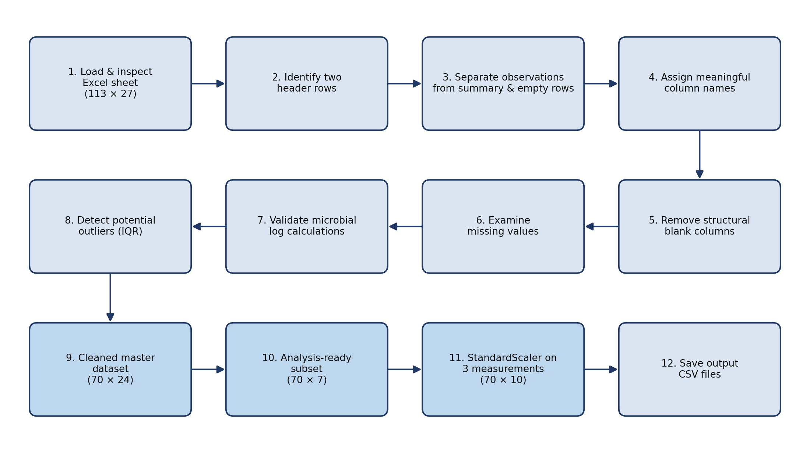
Figure 1. Preprocessing workflow applied to the paneer storage-study sheet. Dimensions are those reported by the notebook.
Table 3. Summary of preprocessing steps
# | Step | Action and outcome
1 | Load and inspect | Read the Excel sheet; it contains 113 rows and 27 columns.
2 | Identify header rows | Two header rows were identified (a multi-row header).
3 | Separate row types | Rows were classified as 70 observations, 28 Mean/SD summary rows, 13 fully empty rows and 2 header rows (70 + 28 + 13 + 2 = 113).
4 | Assign column names | Meaningful single-level column names replaced the two-row header (e.g. TPC_Log10, pH, Moisture_Percent).
5 | Remove blank columns | Structural blank columns were removed, leaving 24 useful columns.
6 | Examine missing values | Missing values were inspected and their causes recorded (Section 7).
7 | Validate log values | Microbial log values were compared with log10(count × 10^dilution); comparable values matched.
8 | Detect outliers | Potential outliers were flagged with the IQR method and retained (Section 8).
9 | Cleaned master dataset | 70 observations × 24 columns.
10 | Analysis-ready subset | 70 observations × 7 selected columns.
11 | Standardization | StandardScaler applied to three measurements; scaled values added as new columns (70 × 10).
12 | Save outputs | Three CSV files written (Table 4).

5.1 Header and row structure
The sheet uses two header rows, so no single row names every column. The two rows were interpreted together and replaced with one set of descriptive column names. The remaining rows were then separated by type. Only the 70 observation rows are raw measurements; the 28 Mean/SD rows are summary statistics and the 13 empty rows carry no data, so keeping them in an analysis table would corrupt counts, means and any scaling.

5.2 Validation of microbial log values
Each microbial log value was checked against the relationship log10(count × 10^dilution), using the count and dilution columns in the same record. Where both the logarithm and the underlying count were available, the recorded values matched the formula. Where a count equals zero the logarithm is mathematically undefined, so the log value is missing; this is expected and is not a data-entry error.

5.3 Derived datasets and output files
The cleaned master dataset keeps all 70 observations and all 24 useful columns. The analysis-ready subset keeps seven columns: the Day and Replicate identifiers, the TPC count and dilution columns, and the three measurements TPC_Log10, pH and Moisture_Percent. The scaled dataset contains these seven columns plus three standardized columns. Table 4 lists the output files.
Table 4. Output files
File | Contents | Shape (rows × columns)
paneer_cleaned_data.csv | Cleaned master dataset | 70 × 24
paneer_analysis_data.csv | Analysis-ready subset | 70 × 7
paneer_scaled_data.csv | Analysis-ready columns plus three standardized columns | 70 × 10

6. Before-and-After Comparison
Table 5. Dimensions of the original and processed datasets
Dataset | Rows | Columns | Nature
Original Excel sheet | 113 | 27 | Raw sheet: headers, observations, summary and empty rows
Cleaned master dataset | 70 | 24 | Observations only, named columns, structural blank columns removed
Analysis-ready dataset | 70 | 7 | Derived subset of the cleaned data
Scaled dataset | 70 | 10 | Derived: subset plus 3 standardized columns

Figure 2 shows how the 113 rows of the original sheet divide into row types.
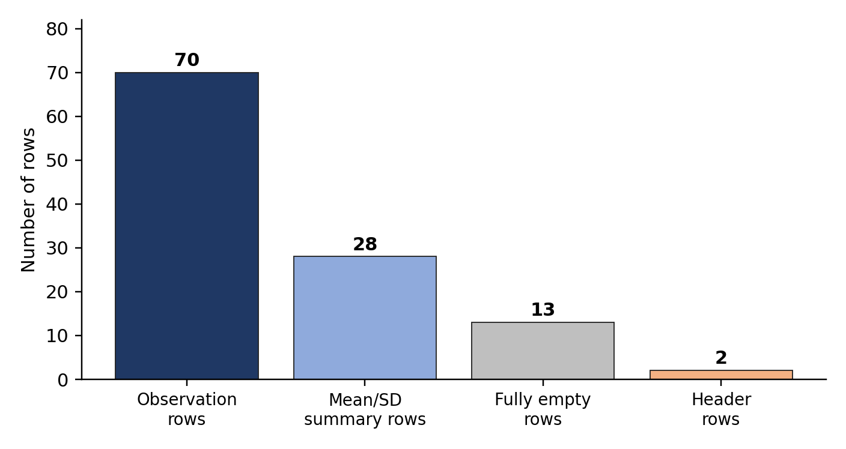
Figure 2. Composition of the 113 rows in the original Excel sheet (70 + 28 + 13 + 2 = 113).
The analysis-ready and scaled datasets are derived datasets, not additional original observations. All three processed files describe the same 70 observations; they differ only in which columns are kept and whether standardized columns are included. The reduction from 27 to 24 columns corresponds to the removal of structural blank columns. The increase from 7 to 10 columns equals the three standardized columns added.

7. Missing-Value Treatment
Missing values in this dataset arise for different reasons and were therefore not handled with a single rule. Table 6 separates them by cause. Not every missing value was imputed or removed.
Table 6. Missing values by cause and treatment
Variable group | Where values are missing | Reason | Treatment
Microbial log values | Records whose microbial count is zero | log10(0) is undefined | Retained as missing where appropriate; not replaced by an arbitrary number
Sensory measurements | Days 10–13 | Sensory data are unavailable for these days | Not fabricated or imputed
Production-related measurements | All days except Day 0 | Values are recorded for Day 0 only | Not fabricated or imputed

Because sensory values are unavailable for Days 10–13 and production-related values exist only for Day 0, neither group can support analysis across the whole observation period.

8. Outlier Analysis
Potential outliers were identified with the interquartile range (IQR) method. For a variable, Q1 and Q3 are the first and third quartiles and IQR = Q3 − Q1. Under the conventional rule, values below Q1 − 1.5 × IQR or above Q3 + 1.5 × IQR are flagged.
Flagged values were retained, not deleted. In a storage study measurements are expected to change over time, so an extreme value may be a real storage-related change rather than a recording error. The IQR rule only marks values that are unusual relative to the spread of the data; it does not show that they are wrong. The flagged observations are therefore held for verification by someone with domain knowledge before any exclusion or correction is considered.

9. Standardization
pH, moisture percentage and log10 microbial counts are measured on different scales, which matters for scale-sensitive methods such as distance-based or regularised models. StandardScaler from scikit-learn rescales each variable to zero mean and unit variance using
z = (x − mean) / standard deviation
where the mean and standard deviation are computed from the data supplied to the scaler (scikit-learn uses the population standard deviation, ddof = 0).
The three standardized variables were TPC_Log10, pH and Moisture_Percent. The scaled values were stored in new columns, so the original measurement columns were preserved alongside them. This is consistent with the shape of the scaled dataset: the 7 analysis-ready columns plus 3 standardized columns give 10 columns, with all 70 rows retained.
After standardization each scaled column is expected to have a mean close to 0 and a standard deviation close to 1. scikit-learn ignores missing values when fitting the scaler and leaves them missing in the output; if TPC_Log10 contains missing values for zero counts, the corresponding scaled entries remain missing.

10. Results and Discussion
Table 7 separates what the notebook established (observed facts) from what follows as interpretation.
Table 7. Observed facts and interpretation
Observed (notebook / data) | Interpretation
The sheet has 113 × 27 cells: 70 observation, 28 Mean/SD, 13 empty and 2 header rows. | Only 70 rows are raw observations; the other rows are layout or summary content and were excluded from the cleaned data.
Observations span Day 0–13 with five replicates per day. | 14 days × 5 replicates = 70, which matches the observation count and indicates a balanced layout.
28 Mean/SD summary rows are present. | This equals 14 days × 2, consistent with a mean row and an SD row per day.
Microbial log values matched log10(count × 10^dilution) where comparable. | The recorded log columns are internally consistent with their counts and dilutions; missing logs correspond to zero counts.
Sensory data are unavailable for Days 10–13; production values exist for Day 0 only. | These groups cannot support analysis over the full period and are not among the seven analysis-ready columns.
IQR flagged potential outliers. | The values may be genuine storage effects or errors; this cannot be decided without domain verification, so they were kept.
Scaled dataset has 70 rows × 10 columns. | Standardized columns are available for scale-sensitive analysis while the original units remain in the data.

Cleaned master dataset versus analysis-ready subset. The cleaned master dataset (70 × 24) is the comprehensive record: it keeps every useful column, including those with structural gaps such as sensory and production measurements. The analysis-ready subset (70 × 7) is a deliberately narrow view for downstream work. It keeps the identifiers (Day, Replicate), the TPC count and dilution, and the three continuous measurements TPC_Log10, pH and Moisture_Percent. The scaled dataset adds standardized versions of the three measurements to that view.
Scope of this work. These results concern data structure and preparation only. No statistical test was run and no claim is made about food safety, shelf life, spoilage or statistical significance. If the scaled data are later used for predictive modelling, the scaler should be fitted on training data only to avoid information leakage.

11. Challenges and Solutions
Table 8. Challenges encountered and how they were handled
Challenge | Solution
Multi-row header: two header rows meant no single row named each column. | Identified both rows and replaced them with one set of descriptive column names.
Summary rows mixed with observations: 28 Mean/SD rows sat among the 70 observations. | Classified rows by type and kept only the observation rows in the cleaned data.
Empty rows and structural blank columns: 13 empty rows and blank columns inflated the sheet to 113 × 27. | Excluded empty rows and removed structural blank columns, giving 70 × 24.
Missing values with different meanings: zero-count logs, unavailable sensory data and Day-0-only production data. | Treated each cause separately; retained missing values and did not fabricate measurements.
Interpreting microbial logarithmic values: log10(0) is undefined. | Validated logs against log10(count × 10^dilution) and kept undefined logs as missing.
Potential outliers that might be real storage-related change. | Flagged with the IQR method and retained pending domain verification.
Different measurement scales across pH, moisture and log counts. | Applied StandardScaler to TPC_Log10, pH and Moisture_Percent, preserving the originals.

12. Conclusion
The Week 2 task converted a layout-oriented Excel sheet of 113 rows and 27 columns into three documented CSV datasets: a cleaned master dataset of 70 observations and 24 columns, an analysis-ready subset of 70 observations and 7 columns, and a scaled dataset of 70 observations and 10 columns. Observation rows were separated from summary and empty rows, missing values were examined and explained rather than hidden, the microbial log values were validated, and potential outliers were flagged but retained.
These files give later analysis a consistent starting point: the master dataset for broad exploration, the analysis-ready subset for focused work on TPC_Log10, pH and Moisture_Percent across Day 0–13, and the scaled dataset for methods sensitive to variable scale. Flagged outliers should be reviewed with domain knowledge before any formal analysis.

13. References
- Storage study data for paneer in controlled RH and Temperature environment, Mendeley Data, Version 2, DOI: 10.17632/rd9dmr54xx.2 (published 17 February 2026; licensed CC BY 4.0).
- Pedregosa, F., et al. (2011). Scikit-learn: Machine learning in Python. Journal of Machine Learning Research, 12, 2825–2830.
- McKinney, W. (2010). Data structures for statistical computing in Python. Proceedings of the 9th Python in Science Conference, 56–61.

